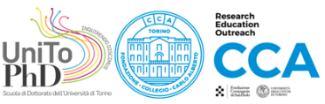 |  |  | 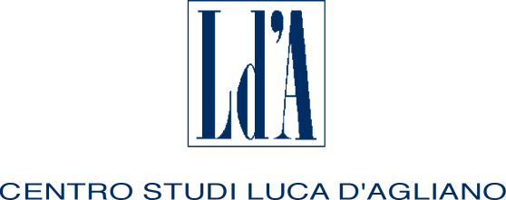 |  | 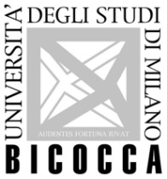
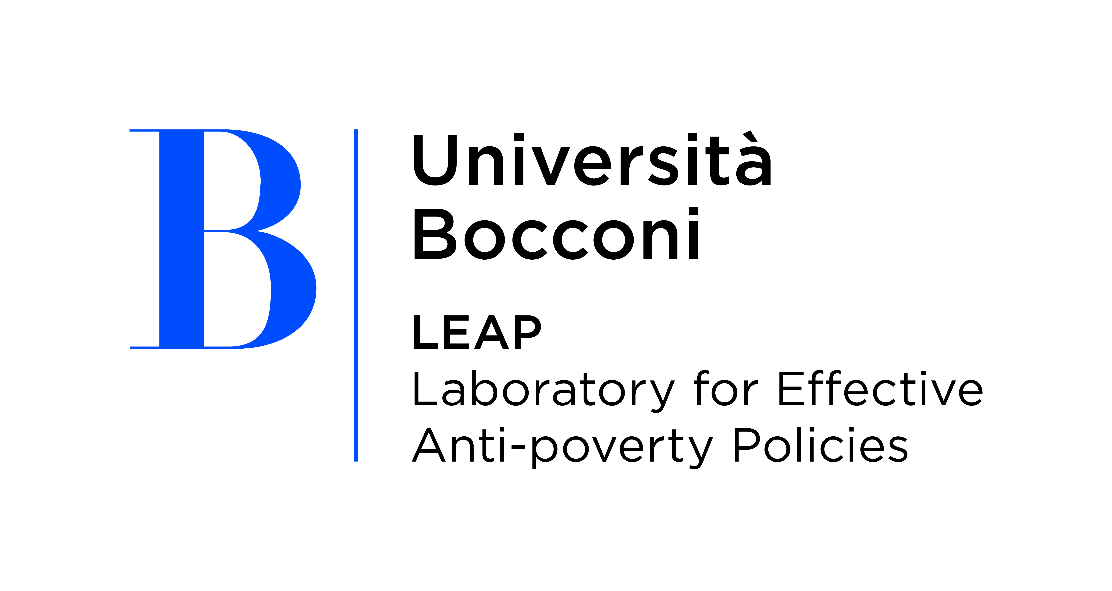 | 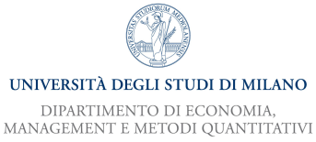 |  |  |  |  | 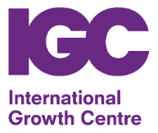

TWENTY-SECOND SUMMER SCHOOL

IN INTERNATIONAL AND DEVELOPMENT ECONOMICS

Gender, Labour and Development

Taryn Dinkelman (University of Notre Dame) and

Rachel Ngai (London School of Economics and CEPR)

Monday 4th to Thursday 7th September 2023

Castello di Gargonza, Tuscany, Italy

Application form
First name: | Family name:
Nationality: | Date of birth: | Sex:
University:
E-mail address:
Mobile phone:
Title of dissertation:
Supervisor:
Thesis completion date (past or expected):
I request funding (only applicants from Developing Countries are eligible): YES NO
I would be interested in presenting my job market paper: YES NO
Please submit this application along with your CV by May 19, 2023 to: centro.dagliano@unimi.it

The activities of the Centro Studi Luca d’Agliano are supported by

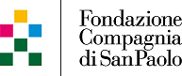

www.dagliano.unimi.it

